**Scheduling Constraints and Fairness Rules**

**Key Mathematical Constraints:**

**Time Constraints T (m, s)** **≤ D**

1. Where: m = number of matches
2. s = time slot duration (match length)
3. D = total available days/time

**Example:**

If s = 2 hours (match duration) m = 4 matches D = 8 hours Then: 4 matches × 2 hours = 8 hours ≤ 8 hours

**Venue Constraints V ≥ ⌈m/t⌉**

1. Where: V = number of venues needed
2. m = concurrent matches
3. t = time slots per day

Example: If m = 7 matches t = 4 time slots Then: V ≥ ⌈7/4⌉ = ⌈1.75⌉ = 2 venues minimum

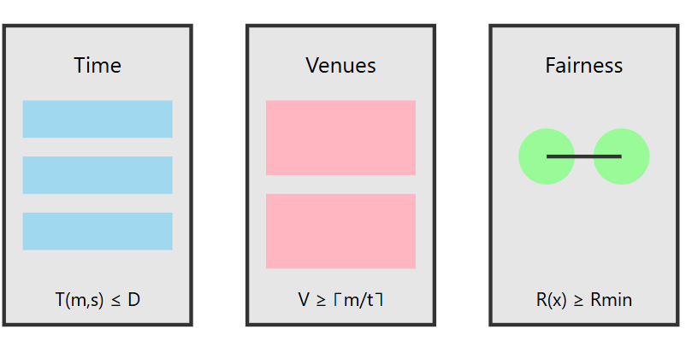

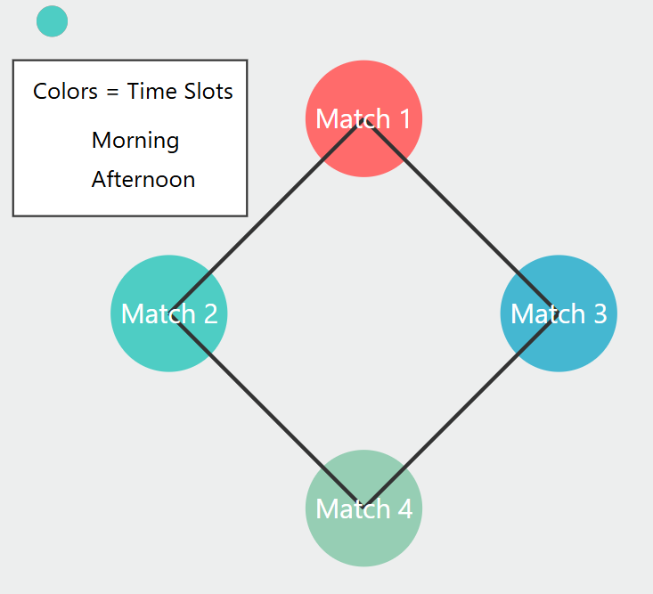

**GRAPH COLORING APPROACH**

* Matches represented as Vertices (V)
* Conflicts shown as Edges (E)
* Time slots assigned as Colors (C)

Example:

* Match 1: A vs B
* Match 2: C vs D
* Match 3: A vs C
* Match 4: B vs D

Then we can draw:

O (A vs B)----------O (A vs C)

| |

| |

O (B vs D)----------O (C vs D)

**HERE:**

• A vs B is connected to A vs C because Team A can't play in both matches at same time.

• A vs B is connected to B vs D because Team B can't play in both

• C vs D is connected to A vs C because Team C can't play in both

• C vs D is connected to B vs D because Team D can't play in both

**FAIRNESS RULES**: For n teams where x, y ∈ {1...n}: |G(x) - G(y)| ≤ 1

This means:

* No team should play consecutive matches
* Teams should have similar number of games
* Fair distribution of morning/afternoon games

Key Benefits:

* Minimizes schedule conflicts
* Ensures equal rest time
* Optimizes resource usage
* Maintains competitive balance